**Mohammad Sultan Bhat**

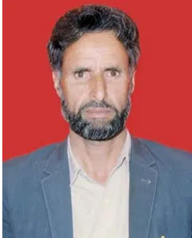

**About:**Mohammad sultan bhat had contested assembly election twice. Within nine years after he lost the election by a whisker, he was assassinated.A resident of Khiram, sultan acquired education up to his middles in his village and then moved to bijbehara for matriculation. Soon after his Bsc. He was appointed a government teacher but sultan resigned and joined Aligarh Muslim University for bachelors in law, a degree he completed in 1971.

**Murdered on:** 13 Aug 1996

**Attack details:**In the night at around 11pm loud knocks were heard on the main door, jawaid said. Before we could respond they broke it open and at least 20 gunmen started calling for mohammad sultan .they took him away.

**Reason to him target:** 2.5 lakh rupees so that she manages his release the family took a few hours to arrange the money and hand it over to her. But she come back with the news he has been killed.

**Occupation :** Sultan joined District Court in Islamabad and emerged as a reputed member of the bar.

**Belief:** sultan was positively responded by the people.

**URL :** <https://kashmirlife.net/mohammad-sultan-bhat-issue-01-vol-08-100162/>

